Assignment 7
Github:
Name: Parth Koshti
PRN: 24070126093
Batch: AIML B1

Title: Student Record Manager: Develop a file-based application to perform CRUD operations on student records with exception handling.

1)StudentRecord.java

import java.io.*;
import java.util.*;

public class StudentRecord {
static final String FILE_NAME = "Students.csv";
static Scanner sc = new Scanner(System.in);

// ── Add student ────────────────────────────────────────────────────────────
static void addRecord() {
try {
System.out.print(" Student ID : "); int studentId = Integer.parseInt(sc.nextLine().trim());
System.out.print(" Name : "); String name = sc.nextLine().trim();
System.out.print(" Branch : "); String branch = sc.nextLine().trim();
System.out.print(" Marks 1 : "); double marks1 = Double.parseDouble(sc.nextLine().trim());
System.out.print(" Marks 2 : "); double marks2 = Double.parseDouble(sc.nextLine().trim());
System.out.print(" Marks 3 : "); double marks3 = Double.parseDouble(sc.nextLine().trim());

BufferedWriter bw = new BufferedWriter(new FileWriter(FILE_NAME, true));
bw.write(studentId + "," + name + "," + branch + "," + marks1 + "," + marks2 + "," + marks3 + ",0,0,0");
bw.newLine();
bw.close();
System.out.println(" ✓ Record added successfully.\n");
} catch (NumberFormatException e) {
System.out.println(" [ERROR] Invalid input: " + e.getMessage());
} catch (IOException e) {
System.out.println(" [ERROR] File operation failed: " + e.getMessage());
}
}

// ── View all records ───────────────────────────────────────────────────────
static void viewRecords() {
try (BufferedReader br = new BufferedReader(new FileReader(FILE_NAME))) {
String line;
System.out.println("\n +-----+----------+----------+--------+--------+--------+--------+--------+-----------+");
System.out.println(" | ID | Name | Branch | Marks1 | Marks2 | Marks3 | Marks4 | Marks5 | Percent |");
System.out.println(" +-----+----------+----------+--------+--------+--------+--------+--------+-----------+");
boolean any = false;
while ((line = br.readLine()) != null) {
if (line.startsWith("studentId")) continue; // Skip header
String[] parts = line.split(",");
if (parts.length == 9) {
System.out.printf(" | %-3s | %-8s | %-8s | %-6s | %-6s | %-6s | %-6s | %-6s | %-9s |%n",
parts[0], parts[1], parts[2], parts[3], parts[4], parts[5], parts[6], parts[7], parts[8]);
any = true;
}
}
if (!any) System.out.println(" No records found.");
System.out.println(" +-----+----------+----------+--------+--------+--------+--------+--------+-----------+\n");
} catch (FileNotFoundException e) {
System.out.println(" [ERROR] File not found: " + e.getMessage());
} catch (IOException e) {
System.out.println(" [ERROR] File operation failed: " + e.getMessage());
}
}

// ── Update student record ─────────────────────────────────────────────────
static void updateRecord(int studentId) {
try {
File file = new File(FILE_NAME);
List<String> lines = new ArrayList<>();
boolean found = false;
BufferedReader br = new BufferedReader(new FileReader(file));
String line;
String header = br.readLine(); // Read header
lines.add(header);
while ((line = br.readLine()) != null) {
String[] p = line.split(",");
if (p.length == 9 && Integer.parseInt(p[0]) == studentId) {
System.out.print(" New Name : "); String name = sc.nextLine().trim();
System.out.print(" New Branch : "); String branch = sc.nextLine().trim();
System.out.print(" New Marks1 : "); double marks1 = Double.parseDouble(sc.nextLine().trim());
System.out.print(" New Marks2 : "); double marks2 = Double.parseDouble(sc.nextLine().trim());
System.out.print(" New Marks3 : "); double marks3 = Double.parseDouble(sc.nextLine().trim());
System.out.print(" New Marks4 : "); double marks4 = Double.parseDouble(sc.nextLine().trim());
System.out.print(" New Marks5 : "); double marks5 = Double.parseDouble(sc.nextLine().trim());
double percentage = calculatePercentage(marks1, marks2, marks3, marks4, marks5);
lines.add(studentId + "," + name + "," + branch + "," + marks1 + "," + marks2 + "," + marks3 + "," + marks4 + "," + marks5 + "," + String.format("%.2f", percentage));
found = true;
} else {
lines.add(line);
}
}
br.close();
if (found) {
BufferedWriter bw = new BufferedWriter(new FileWriter(file));
for (String l : lines) { bw.write(l); bw.newLine(); }
bw.close();
System.out.println(" ✓ Record updated successfully.\n");
} else {
System.out.println(" [ERROR] Student ID " + studentId + " not found.\n");
}
} catch (FileNotFoundException e) {
System.out.println(" [ERROR] File not found: " + e.getMessage());
} catch (IOException e) {
System.out.println(" [ERROR] File operation failed: " + e.getMessage());
} catch (NumberFormatException e) {
System.out.println(" [ERROR] Invalid input: " + e.getMessage());
}
}

// ── Delete student record ─────────────────────────────────────────────────
static void deleteRecord(int studentId) {
try {
File file = new File(FILE_NAME);
List<String> lines = new ArrayList<>();
boolean found = false;
BufferedReader br = new BufferedReader(new FileReader(file));
String line;
String header = br.readLine(); // Read header
lines.add(header);
while ((line = br.readLine()) != null) {
String[] p = line.split(",");
if (p.length == 9 && Integer.parseInt(p[0]) == studentId) {
found = true;
}
else lines.add(line);
}
br.close();
BufferedWriter bw = new BufferedWriter(new FileWriter(file));
for (String l : lines) { bw.write(l); bw.newLine(); }
bw.close();
if (found) {
System.out.println(" ✓ Record deleted successfully.\n");
} else {
System.out.println(" [ERROR] Student ID " + studentId + " not found.\n");
}
} catch (FileNotFoundException e) {
System.out.println(" [ERROR] File not found: " + e.getMessage());
} catch (IOException e) {
System.out.println(" [ERROR] File operation failed: " + e.getMessage());
} catch (NumberFormatException e) {
System.out.println(" [ERROR] Invalid input: " + e.getMessage());
}
}

// ── Calculate percentage ──────────────────────────────────────────────────
static double calculatePercentage(double m1, double m2, double m3, double m4, double m5) {
return (m1 + m2 + m3 + m4 + m5) / 5.0;
}

// ── Update percentage for all students ──────────────────────────────────
static void updatePercentageForAll() {
try {
File file = new File(FILE_NAME);
List<String> lines = new ArrayList<>();
BufferedReader br = new BufferedReader(new FileReader(file));
String line;
String header = br.readLine(); // Read header
lines.add(header);
boolean updated = false;
while ((line = br.readLine()) != null) {
String[] p = line.split(",");
if (p.length == 9) {
try {
double m1 = Double.parseDouble(p[3]);
double m2 = Double.parseDouble(p[4]);
double m3 = Double.parseDouble(p[5]);
double m4 = Double.parseDouble(p[6]);
double m5 = Double.parseDouble(p[7]);
double percentage = calculatePercentage(m1, m2, m3, m4, m5);
lines.add(p[0] + "," + p[1] + "," + p[2] + "," + p[3] + "," + p[4] + "," + p[5] + "," + p[6] + "," + p[7] + "," + String.format("%.2f", percentage));
updated = true;
} catch (NumberFormatException e) {
lines.add(line);
}
} else {
lines.add(line);
}
}
br.close();
if (updated) {
BufferedWriter bw = new BufferedWriter(new FileWriter(file));
for (String l : lines) { bw.write(l); bw.newLine(); }
bw.close();
System.out.println(" ✓ Percentages updated for all students.\n");
}
} catch (FileNotFoundException e) {
System.out.println(" [ERROR] File not found: " + e.getMessage());
} catch (IOException e) {
System.out.println(" [ERROR] File operation failed: " + e.getMessage());
}
}

public static void main(String[] args) {
System.out.println("\n╔══════════════════════════════════════╗");
System.out.println("║ Student Record Management ║");
System.out.println("╚══════════════════════════════════════╝\n");
while (true) {
System.out.println(" 1. Add Student 2. View All 3. Update Record");
System.out.println(" 4. Update Percentage 5. Delete Record 0. Exit");
System.out.print(" Choice: ");
int ch;
try { ch = Integer.parseInt(sc.nextLine().trim()); }
catch (NumberFormatException e) {
System.out.println(" [ERROR] Invalid input: " + e.getMessage() + "\n");
continue;
}
switch (ch) {
case 1:
System.out.println("\n--- ADD STUDENT ---");
addRecord();
break;
case 2:
System.out.println("\n--- VIEW ALL RECORDS ---");
viewRecords();
break;
case 3:
System.out.println("\n--- UPDATE RECORD ---");
System.out.print(" Student ID to update: ");
try {
updateRecord(Integer.parseInt(sc.nextLine().trim()));
}
catch (NumberFormatException e) {
System.out.println(" [ERROR] Invalid input: " + e.getMessage() + "\n");
}
break;
case 4:
System.out.println("\n--- UPDATE PERCENTAGE ---");
updatePercentageForAll();
break;
case 5:
System.out.println("\n--- DELETE RECORD ---");
System.out.print(" Student ID to delete: ");
try {
deleteRecord(Integer.parseInt(sc.nextLine().trim()));
}
catch (NumberFormatException e) {
System.out.println(" [ERROR] Invalid input: " + e.getMessage() + "\n");
}
break;
case 0:
System.out.println("\n Goodbye!\n");
sc.close();
return;
default:
System.out.println(" [ERROR] Invalid option. Please try again.\n");
}
}
}
}

Output:
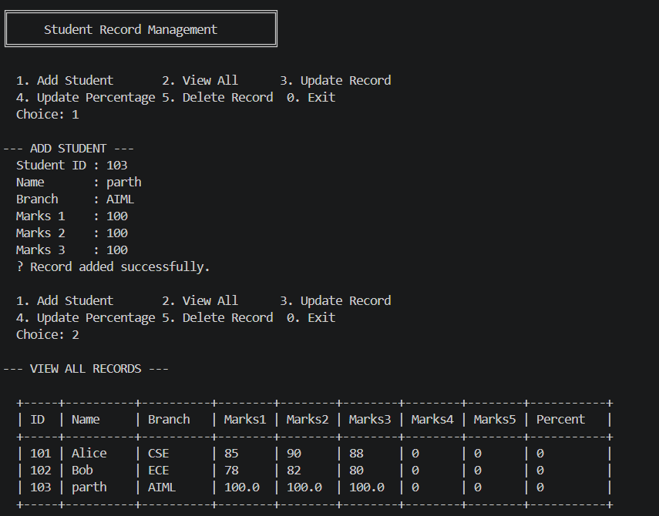

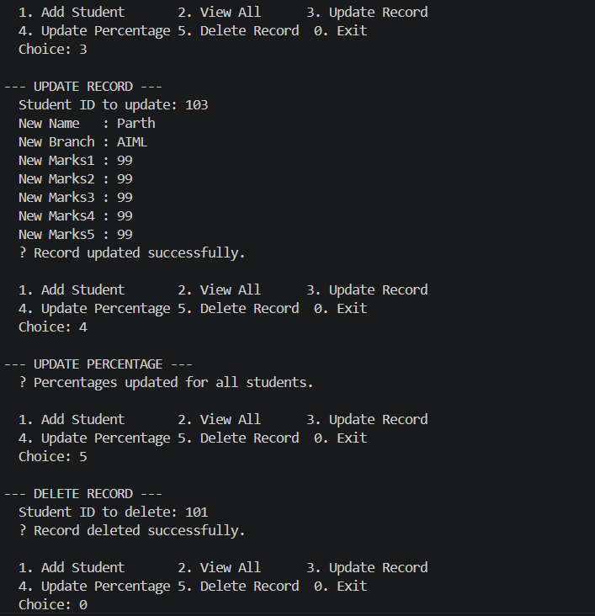

Exceptions:

